README File for dataset -
Fluvial_Clastic_Point_Bar_flow_perpendicular
This dataset includes:
- A photograph of the original 2D (vertically-oriented) sedimentary relief peel specimen from which the data are derived (see Meckel, 2013, JSR reference).
- Data files (.csv, .mat) containing X-Y-Z-K-P values, where:
  - X is horizontal distance perpendicular to flow direction (total length 0.25 m),
  - Y is distance parallel to flow direction (single cell, as this is a 2D dataset essentially),
  - Z is vertical distance in a stratigraphic sense (total length 0.5 m)
  - K is permeability in mD
  - P is threshold pressure (Pth) in kPa
.mat file is 3,125,000 rows by 5 columns (1250x by 2500z =3,125,000)
To obtain specimen dimensions of 0.25 m wide and 0.5 m tall (same as Meckel, 2013), use:
dX = 0.0002 m (1250 values x 0.0002 m = 0.25 m wide)
dY = 0.01m (this is a 2D model, so Y-dimension is a single cell with defined dimension – this value makes mode 1 cm thick in Y-direction)
dZ = 0.0002 m (2500 values x 0,0002 m = 0.5 m tall)

Permeability (mD) and Threshold Pressure (Pth in kPa) value ranges are shown in this plot:
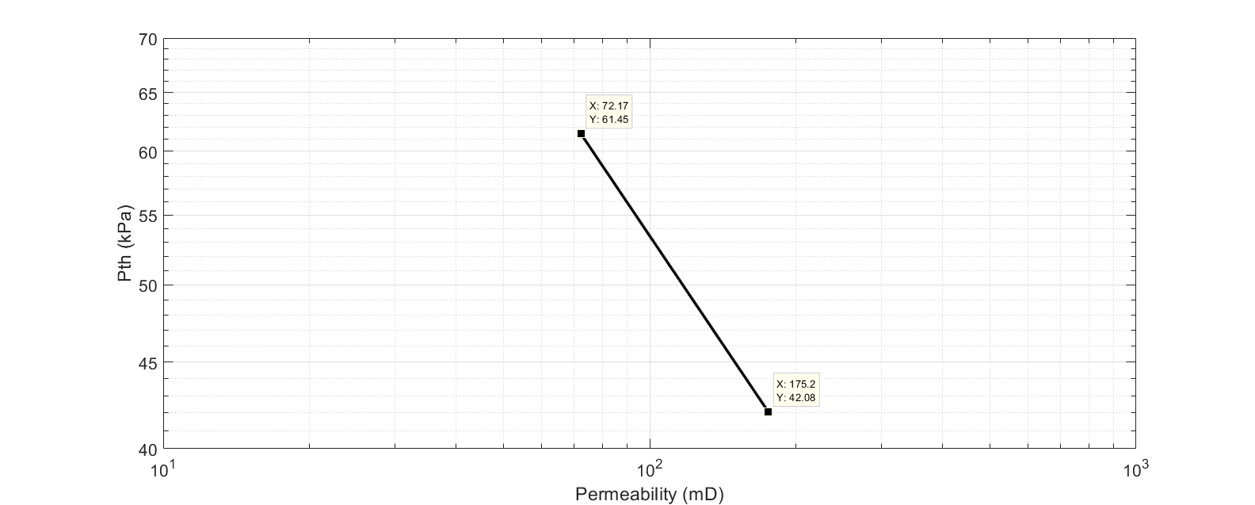
This relationship is defined from Sorkhabi and Tsuji, 2005, AAPG Memoir 85: The place of faults in petroleum traps, with conversion of PSI to kPa.

